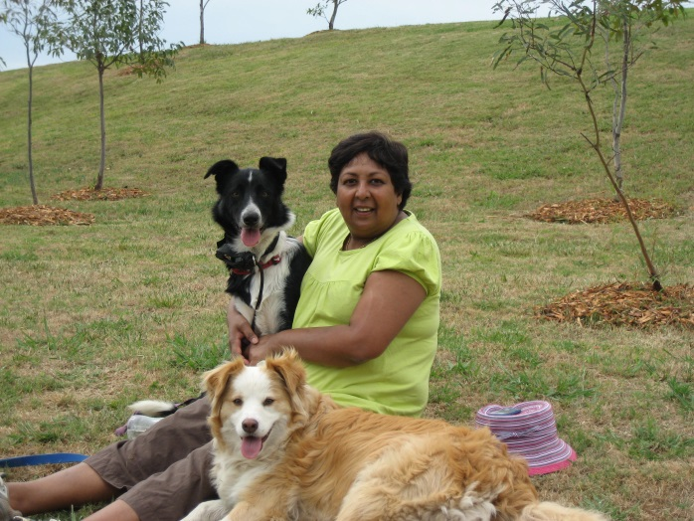
GUEST SPEAKER PREMA D’CRUZ INVITATION FORM

Email the completed form to laddiesstory@glenndc.com

SPEAKER PREMA D’CRUZ
Lawyer/Radiographer/Toastmaster

Purpose of Presentation:
I am a Toastmaster and Storyteller looking to entertain people with stories that touch our hearts about our pets and also teach us invaluable lessons. My presentation revolves around making audiences appreciate the companionship of animals, consider donating to the RSPCA (which is my charity of choice) and as well laugh at Laddie’s story (a true story)

My Contact Details:
Mobile: 041 123 8737 Email: laddiesstory@glenndc.com
Website: www.laddiesstory.com
Brief description and length of the presentation: I present 3 stories (Total length 45 minutes ) Stories are from the book Laddie’s Story available for purchase on the day ($15) and online at www.laddiesstory.com ($22.50 includes postage). The stories are good news stories about Laddie, a dog adopted from the RSPCA and the important messages learnt from this adoption.

Fee for this presentation
A fee of $50 to cover costs for travel. Clubs may opt to make a donation to the RSPCA

YOUR DETAILS

Club Name ____________________________________________________
Club Address ____________________________________________________
Contact Person ____________________________________________________
Contact Telephone ____________________________________________________
Contact Mobile ____________________________________________________
Contact email address ____________________________________________________

Number of attendees (approximate) ______________

Time of presentation Day Afternoon Evening (please circle) Time ______________

Is there access to a projector ______________ ( I will provide my own laptop)

Is there access to a microphone ______________ (preferred for audiences over 80 attendees)

Any Additional information about the organization and it’s aims: _________________

_____________________________________________________________________________________________

